**Battleport**

Rotterdam edition

**Concept**

**This paragraph shows the general idea we came up with for our project. We will discuss the concept and initial gameplay.**

**Main goal:**

The main objective of our game is to destroy all of the opponent’s battleships. Do this by strategically moving your ships and using the various cards to your advantage.

**Setup rules:**

Every players starts off with fourships and two cards. First of all, the players (P1, P2) start placing his ships at the bottom of the board (turn based). When all ships are placed, P1 draws his first card. P2 draws after P1 until both have two cards.

**Stance:**

During this game you can have your ships in two different stances, offense and defensive. Offensive stance allows you to move and have regular range. Defensive allows for no movement but grants you one extra range. However, defensive ships can only shoot vertically.

**Cards:**

***Main deck:*** the main deck contains most cards. *Offensive, defensive* and *utility* are all inside this deck. Most of these cards can only be used during your own turn. However, some of these cards are *trap cards.* These cards have to placed face down onto the designated area. While these cards are placed, they can be activated at any time.

***Special:*** These cards are in a separate deck. They can be earned by getting a ship to the other side of the map, much like checkers. Their effects vary but all are upgrades to your ship. The effect of these cards are active for the rest of the game.

**Rules:**

*Start*

* + Each player draws 2 card to start with.
  + Each player will take turns and place their ships on the field one by one, The ships must touch their starting lines with their rears.

*Normal Cards*

* + Player draws 1 card when it’s their turn.**(check card description for effect and usage)**
* When a trap card is drawn , the trap card must be immediately placed face down on the trap card field.
* Trap cards may always be activated even during the turn of the other player.
  + A player may have up to 6 cards in their hand, any card drawn after this amount will go to the discard pile.
  + Player may use up to 2 cards in their turn.
  + When the normal deck runs out of cards , shuffle the discard pile and make this the new normal card deck.

*Moves and stances*

* + Player may move all their ships in one turn corresponding to the amount of steps each ship may move.**(check ship stats)**
  + Player may change ships from stance , changing stance will take away 1 step from the total movement that ship may do in one turn.
* When a ship is placed in defensive stance (**vertically**), the ship will gain alternate ranges and allowed steps. **(check ship stats)**
* When a ship is placed in defensive stance , the ship becomes immobile and is not able to take steps until stance is changed back to offensive.**(utility cards still have effect)**.
  + Player may engage the opponent twice in one turn if the ships are in range corresponding to the range of the ships used to engage.**(check ship stats)**
  + A single ship may only engage once in a turn.

*Special cards and end line*

* + When a player reaches the end line with one of their ships, player may draw a card from the special card deck and must play it. If the special card is a perk, the perk must be used on the ship that reached the end line. The effect of a perk will remain on the ship until the ship is destroyed.

*Winning conditions*

* + When a ship reaches 0 health points , ship is destroyed , a destroyed ship will remain on the playing field as an obstacle to which other ships cannot pass thru.
  + Player wins when all opponent’s ships are destroyed.

**Gameplay:**

At the start of a turn, the player at hand draws a card from the “normal” deck. A card may be used before attacking.

Player 1 may move his ships. If a player 1’s ship is in range of a player 2 ship, player 1 may attack. (Only two ships may attack per turn) Instead of attacking you may also change your ship's stance. Then player 1’s turn ends.

**Turn shortened into steps:**

1. Draw a “normal”card.
2. Card may be used.
3. Move ships
4. Attack a ship or change stance
5. Move ships (if steps left)
6. End turn

**Ship stats**

|  |  |  |  |  |
| --- | --- | --- | --- | --- |
| **Name (size)** | **HP** | **Moveset** | **Offensive Range** | **Defensive range** |
| Furgo Saltire & Santa Bettina(2) | 2 | 3 steps | Horizontal range of 2, Vertical range of 2 | Vertical range of 3 |
| Silver whisper & Windsurf  Sea Spirit & Intensity (3) | 3 | 2 steps | Horizontal range of 3, Vertical range of 3 | Vertical range of 4 |
| Merapi & Amadea(4) | 4 | 1 step | Horizontal range of 4, Vertical range of 4 | Vertical range of 5 |

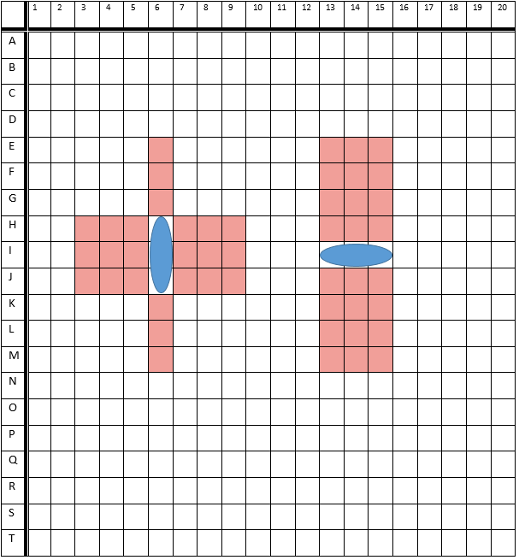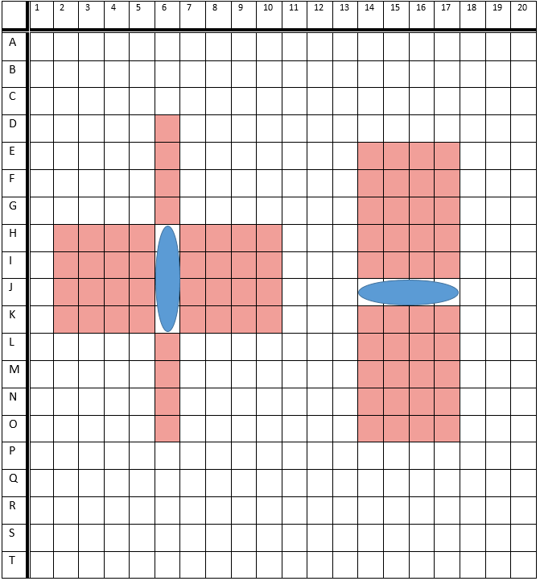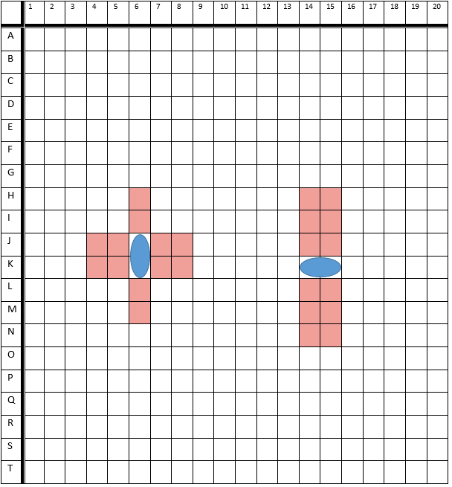

**Normal deck includes:**

Offensive

2x **FMJ upgrade:** When this card is used, your next shot does +1 damage

2x **Rifling:** When this card is used, your next shot has +1 range

2x **Advanced Rifling:** When this card is used, your next shot has +2 range

6x **Naval Mine:**Activates the mine with coordinate X,Y (trap)

4x **EMP upgrade:** When this card is used, your mine or shot will disable the movement and attack of the ship(s) that got hit with this EMP for the next opponent's turn

**TOTAL: 16 cards**

Defensive

2x **Reinforced Hull:** Adds one HP to a friendly ship of your choice when this card is played.

4x **Sonar:**  Choose a potential mine location to spot and deactivate that mine, if a mine is spotted, the trap card the mine belongs to gets discarded.

2x **Smokescreen**: When a friendly ship gets attacked, you may activate this card to make the attack miss. *(trap)*

2x **Sabotage**: When activated, your opponent's attack deals damage to its own ship *(trap)*

**TOTAL: 10 cards**

Utility:  
2x **Backup:** Draw two cards

4x **Extra Fuel II:** Select a friendly ship to make its move +2 steps

6x **Extra Fuel:** Select a friendly ship to make its move +1 step

1x **Rally:** All friendly ships can move +1 step

4x **Adrenaline rush**: Select a friendly ship to make its moveset x2

**TOTAL: 17 cards**

**Special deck includes:**

Special:

2x **Repair**: Select a friendly ship to heal this ship to it’s base HP

2x **Flak armor**: Ship becomes immune to mines *(perk)*

1x **Hack Intel:** Reveal the first three cards in the special deck, choose one and shuffle the other back into the deck

1x **Far sight:**  The used ship now has +2 range *(perk)*

1x **Aluminum hull**: The used ship now has its moveset x2 *(perk)*

1x **Jack Sparrow:** Reveal opponent's hand, choose 1 of his cards and discard another 1

**TOTAL: 8 cards**

**Flowcharts:**

Flowchart setup Flowchart turn



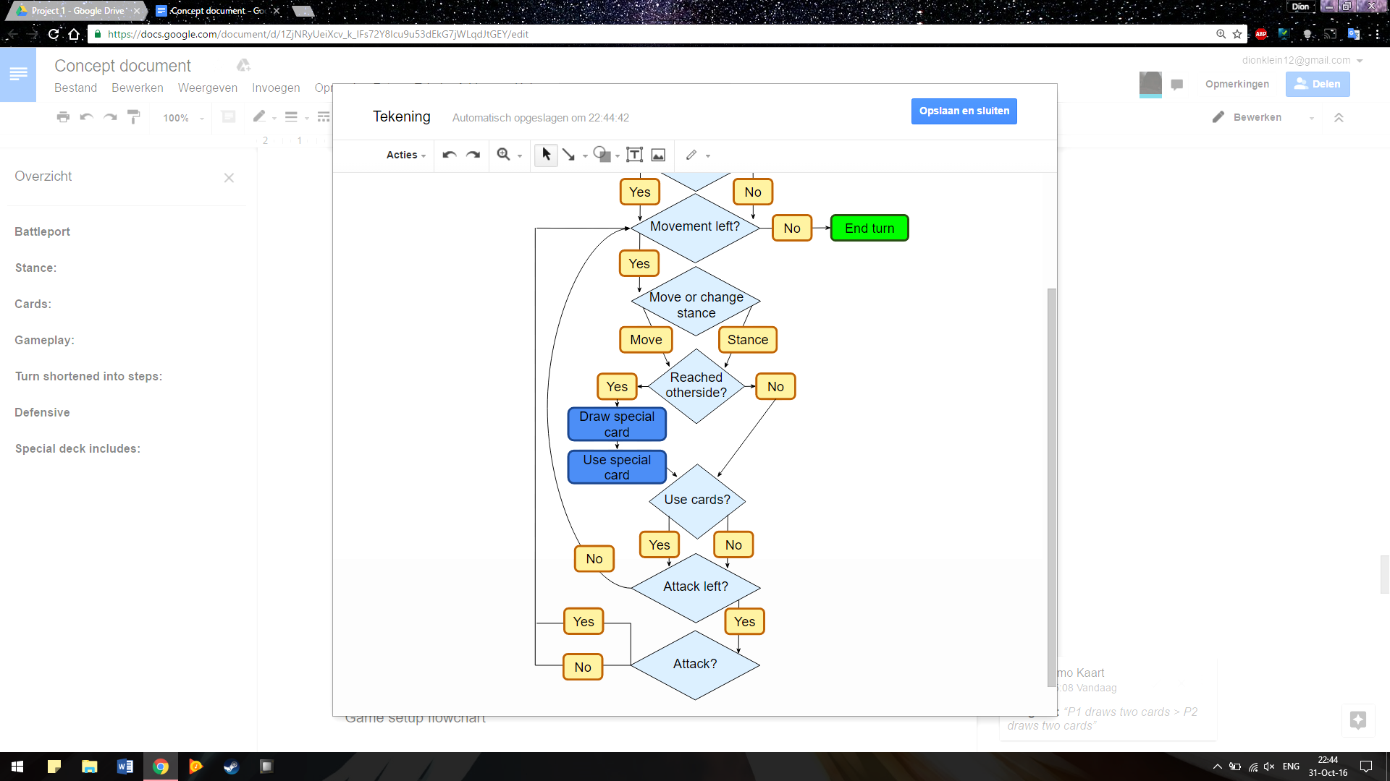

Not all steps have to be used before attacking, you can move, attack and move.

Game setup flowchart



**Problemen**

Playtest 1 Dion en Erik:

Na de eerste playtest kwamen we erachter dat het spel veels te langzaam gaat. Het speelveld was te groot, er waren te weinig hulpkaarten, per beurt mag er maar 1 schip per keer bewegen en de schepen mochten alleen maar voorwaarts aanvallen. Ook kwamen we erachter dat de kaarten niet goed verdeeld waren. De EMP mijnen waren verwarrend. De 2 damage kaarten waren niet sterk genoeg voor een speciale kaart.

nieuwe type kaart

Gesprek PO:

Het concept van de notitieblok om de coördinaten van de mijnen op te schrijven moest aangepast worden. Het moet zelf een onderdeel van het bordspel zijn. Na de usability test ‘rules aanpassen’ toevoegen in sprint backlog.

flowchart aanpassen

Analyse docent:

De flowchart, usability test, storyboard bespreken

Playtest 2 Sandro vs Patrik:

- Wat is de beginlijn  
- Rules gelijk laten zien in plaats van setup tekst (flowchart ook?)  
- Mines detected?? (Game rules)  
- Kaarten moeten duidelijke beschrijving hebben (schild, trap)  
- Meerdere damage als schip in bereik   
- Meerdere schepen hoor je te kunnen raken als ze binnen bereik zijn  
- Volgorde flowchart change stance kan ook naast move ship bovenin  
- Defensive stance verticaal niet kunnen worden geraakt

- stance veranderen telt als stap in plaats van een aanval beurt

usability test:

* EMP kaarten kunnen op elk moment ingezet worden
* letten op timing activeren van mine
* trap kaart gelijk op veld
* max. 2 kaarten per beurt mag worden ingezet (excl trap cards)

**Oplossingen**

beginnen zonder spawn.

betere uitleg over def/offensive stance, zij kanonnen

***Nieuw trap idee:

Op het speelveld staan al een stuk of 9 “Naval mines

” geplaatst. een mine trap card heeft de coördinaat van één van de 9 traps. Wanneer je dus een mine trap card trekt, krijg je de keuze om deze mine te activeren. EMP mine ideeën?

combo’s

|  |  |  |
| --- | --- | --- |
| 1 Offensive | EMP upgrade + Naval mine | All ships hit by the naval mine will have its actions disabled for the next turn. |
| 2 Offensive | EMP upgrade + FMJ upgrade | You next shot has +1 damage and the ship that has been hit will have its actions disabled for the next turn. |
| 3 Offensive | EMP upgrade + Rifling | Your next shot has +1 range and the ship that has been hit will have its actions disabled for the next turn. |
| 4 Offensive | EMP upgrade + Advanced Rifling | Your next shot has +2 range and the ship that has been hit will have its actions disabled for the next turn. |
| 5 Offensive | FMJ upgrade + Rifling | Your next shot has +1 damage and +1 range and the ship that has been hit will have its actions disabled for the next turn. |
| 6 Offensive | FMJ upgrade + Advanced Rifling | Your next shot has +1 damage and +2 range and the ship that has been hit will have its actions disabled for the next turn. |
| 7 Utility | Extra fuel + Extra fuel 2 | Selected ship has + 3 steps |
| 8 utility | Adrenaline rush + Extra fuel | Selected ship has his moveset x2 +1 step |
| 9 utility | Adrenaline rush + Extra fuel 2 | Selected ship has his moveset x2 +2 steps |